**Portfolio Management: Analysis and Prediction**

**Introduction**

This project analyzes the historical performance of a diversified investment portfolio consisting of stocks, bonds, and gold. The primary objectives are to assess the portfolio's risk and return characteristics, visualize key performance metrics, and develop a basic predictive model to forecast future returns.

**Data Collection**

The data was sourced from Yahoo Finance, covering the daily closing prices of the S&P 500 (SPY), a US Treasury Bond ETF (TLT), and a Gold ETF (GLD) over the past five years.

**Portfolio Allocation**

The portfolio allocation was set as 50% stocks (SPY), 30% bonds (TLT), and 20% gold (GLD). The weighted returns were calculated based on these allocations to track the portfolio's performance.

**Performance Metrics**

Key performance metrics were calculated:

* **Annualized Volatility**: Measures the risk of the portfolio.
* **Sharpe Ratio**: Assesses the risk-adjusted return.
* **Maximum Drawdown**: Identifies the largest peak-to-trough decline in the portfolio's value.

**Visualizations**

Several visualizations were created to better understand the portfolio:

* **Portfolio vs. Asset Performance**: Compares the cumulative returns of the portfolio against individual assets.

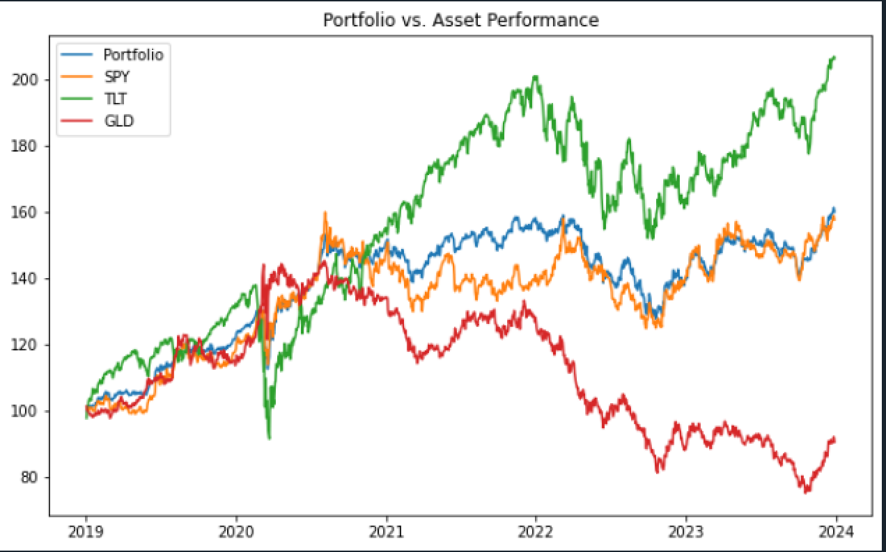

* **Rolling Volatility**: Displays the portfolio's volatility over time.

* **Correlation Heatmap**: Illustrates the relationships between the assets.

* **Portfolio Daily Return Distribution**: Shows the distribution of daily returns.

**Predictive Analysis**

A simple linear regression model was used to predict the next day's portfolio return based on past returns. The model's performance was evaluated using Mean Squared Error (MSE).

**Conclusion**

This project showcases the application of Python in portfolio management, providing insights into the portfolio's risk-return profile and laying the groundwork for future enhancements in predictive modeling and portfolio optimization.